WEEKLY STATUS REPORT
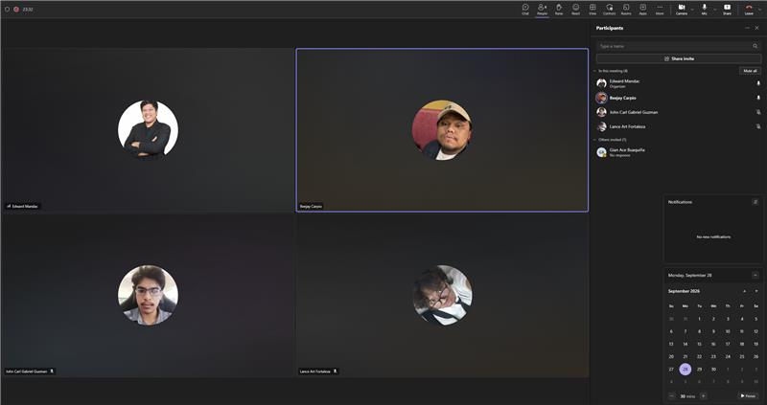
Date: 09-28-2026
Meeting Called By: Cache Flow
Facilitator: Sir Edward Mandac
Link of the Meeting: Cache Flow - Weekly Status Meeting-20260928_184546-Meeting Recording.mp4

Attendees
Beejay A. Carpio
Lance Art P. Fortaleza
John Carl Gabriel Guzman

Agenda
- sprint tracker updates, and backlog tweaks.
- Review additional documentation requirements (C4 code diagrams and test cases)
- Align prototype behavior with documentation and client expectations
- Plan upcoming sprint retrospective, and makeup weekly status sessions

Summary
Reported minor backlog adjustments to incorporate sign-in user stories and noted new requirements from Sir Sean for a C4 Code Diagram focusing on the prototype and formal test cases. Sir Edward instructed the team to ensure the prototype aligns with documentation; if discrepancies exist, the documentation should be updated to reflect logical prototype behavior while verifying client expectations with Ms. April. Guidelines were provided for logging actual daily hours in the sprint tracker to completing sprint retrospective sections, documenting impediments/bugs, and preparing test case for cross-group testing.

